Dynatrace AppMon Questionnaire for



Prepared by:
PT Mitra Integrasi Informatika
APL Tower, Lt. 37ᵗʰ Suite 1- 8
Jl. Letjen S. Parman Kav. 28
Jakarta 11470

Date: July 27, 2018 Version: 1.0

Systems to be analyzed
- What kind of Application that you need Dynatrace AppMon to monitor ?
For example :
- Agency Link, it is an application that used for...
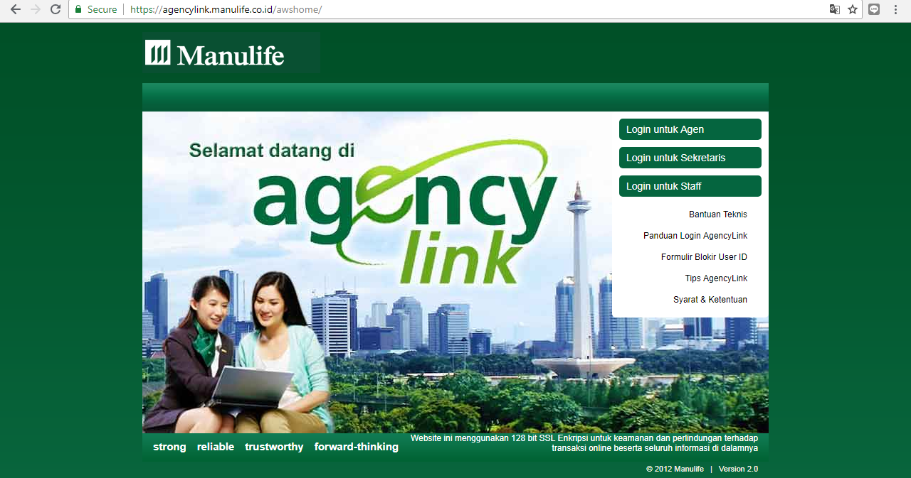
- Partner Link, ...
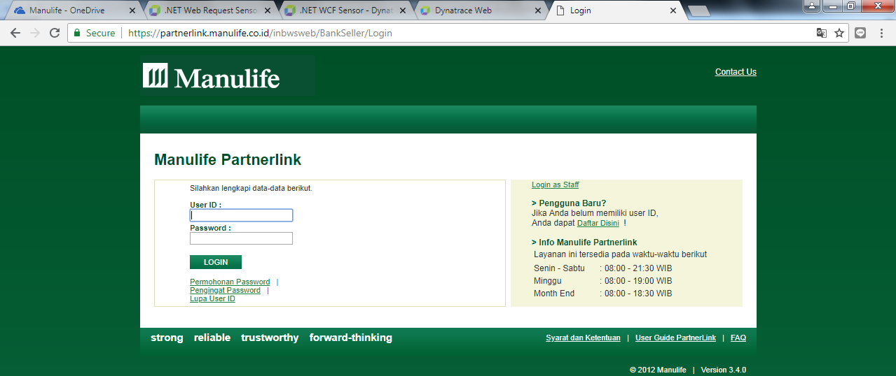

...

- What kind of technology that you use for the application ?
For example :
- For Agency Link. It’s a .NET Application with IIS Web Server
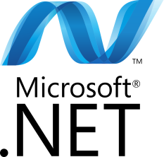
- For Partner Link. ...
...

- What information that you need to monitor from this application ?
For example :
- Availability of application
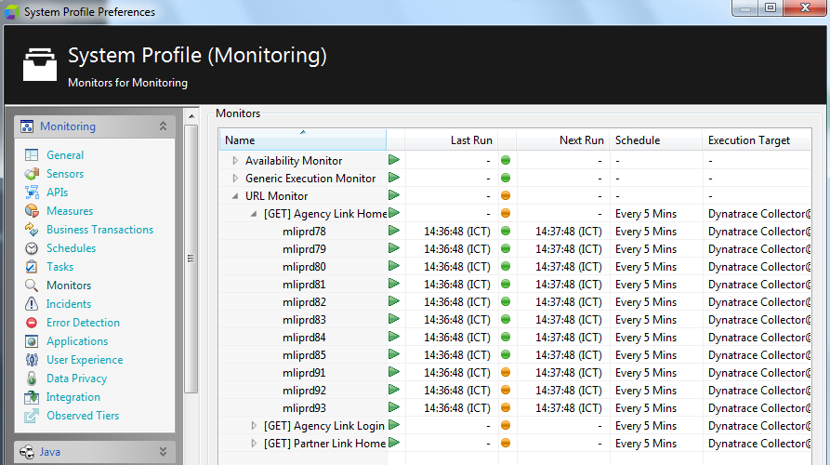
- Availability of host, etc...
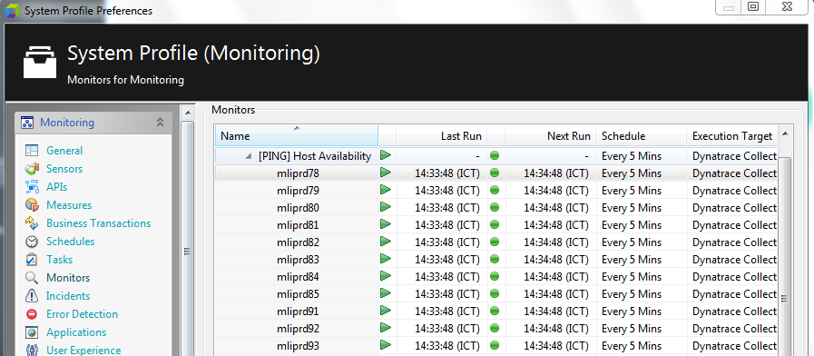

...

- What kind of Dashboard that you need to monitor this application ?
For example : A dashboard that can help to maintain the availability of host and application for Agency Link & Partner Link
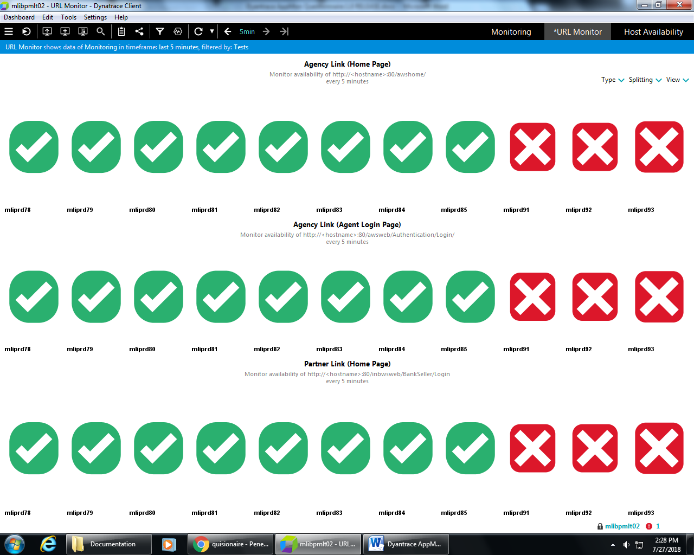
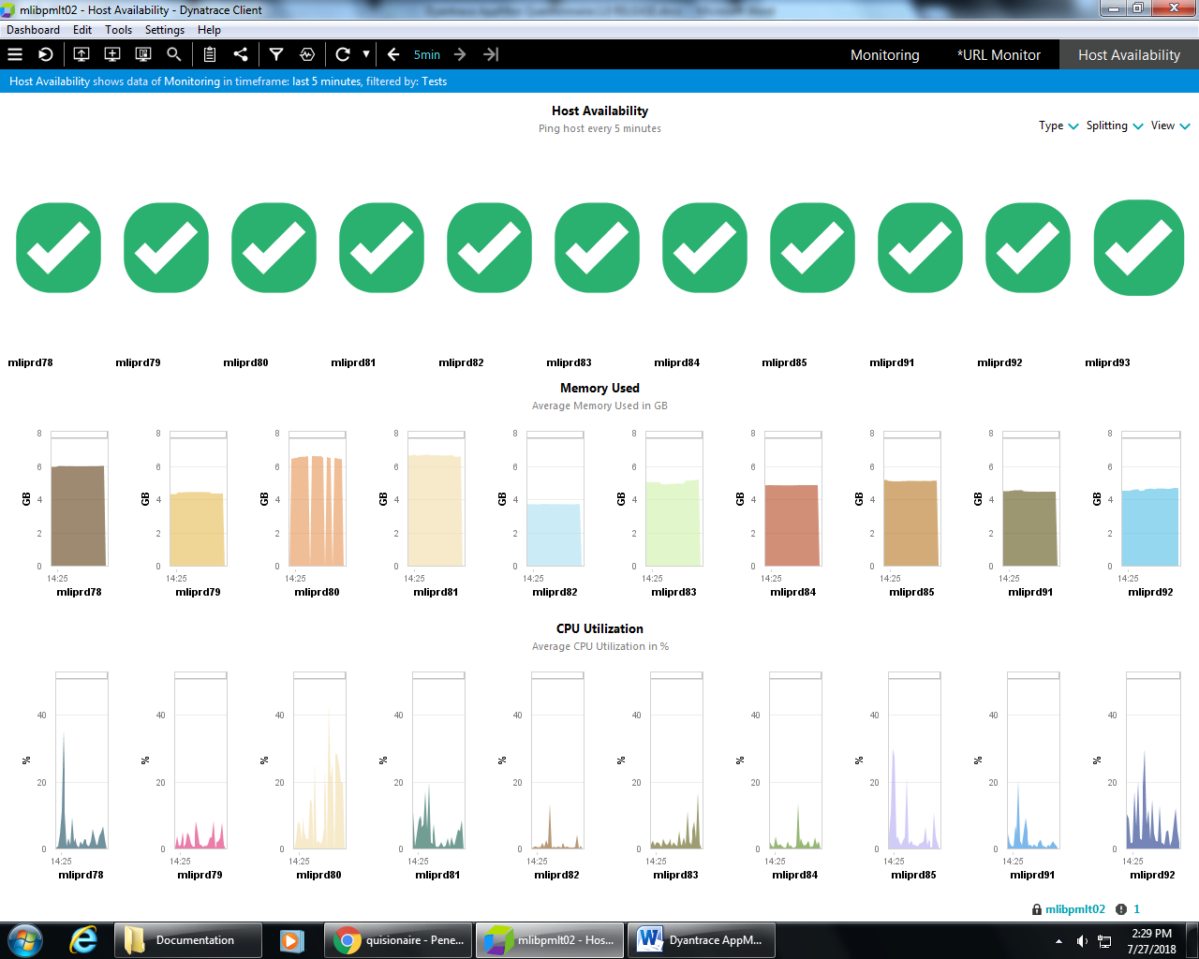

...

- What kind of detection/alert that you need for this application ?
For example : An e-mail alert for detect if the application can’t be accessed or not available (error).
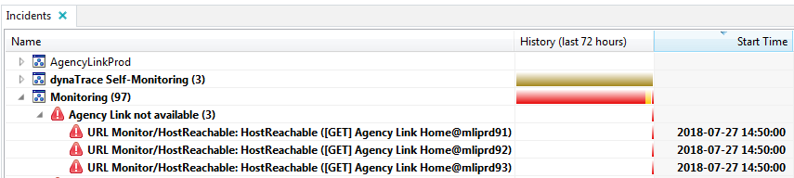

...

- Specify any crucial service that you need to monitor with AppMon
For example : Agency Link : awsweb/Authentication/...
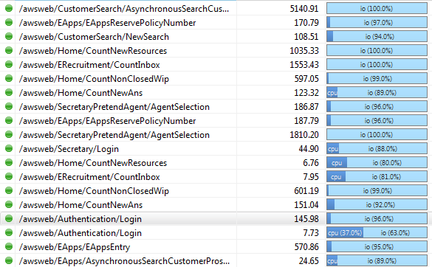

...

- Do you have any special request for this implementation ?
For example : Need scheduler to maintain server date & time for every host...
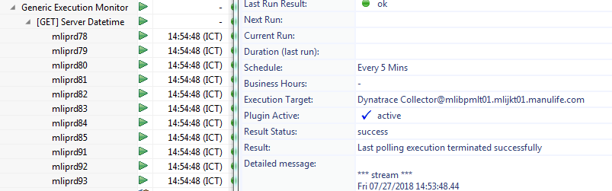

...

- Specify any user w/ roles that use Dynatrace AppMon ?
For example :
- A as Administrator User
- B as User
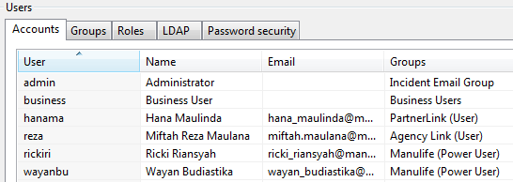

...

- What application that you want to monitor using Dynatrace AppMon Synthetic Monitoring?
For example :
- Agency Link (agencylink.maulife.com)
- Partner Link (partnerlink.maulife.com)
...

